**Lesson10 Class Binding in Angular**

**Notes:-**

**1-If you want to use the Binding Class in specific element , it will replace the previous CSS Class with it**

**Exmaple:-**

**If we set the following css class**

.Main

{

color: red;

font-size: 18px;

}

.MainSizeType

{

font-style: italic;

}

**And set the Class like the below example**

@Component({

selector: 'app-employee',

//we see that the css Class Binding overwrite the previous css Class

template: '<h1 class="Main" [class]="FontStyle">Hello world</h1>',

styleUrls: ['./employee.component.css']

})

export class EmployeeComponent implements OnInit {

public FontStyle="MainSizeType";

}

**2-if you want to add new class and change it like show / hide as you want , you can use this expression like :-**

**[class.MainSizeType]="BoldToApply"**

**The First Argument is the cssClass , and the second argument is the property**

@Component({

selector: 'app-employee',

//we see that the property binding in this state does not overwrite the previous cssClass

template: '<h1 class="Main" [class.MainSizeType]="BoldToApply">Hello world</h1>',

styleUrls: ['./employee.component.css']

})

export class EmployeeComponent implements OnInit {

public BoldToApply:boolean = true;

public FontStyle="MainSizeType";

}

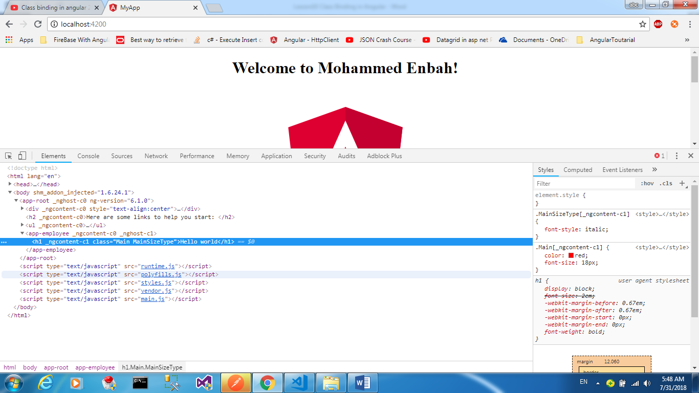

**3-if you want to remove specific class from array of class , we use the property binding as the previous example**

@Component({

selector: 'app-employee',

// templateUrl: './employee.component.html',

template: '<h1 class="Main MainSizeType" [class.MainSizeType]="BoldToApply">Hello world</h1>',

styleUrls: ['./employee.component.css']

})

export class EmployeeComponent implements OnInit {

public BoldToApply:boolean = false;

}

**We see that the result will be**

<h1 class="Main”>Hello world</h1>

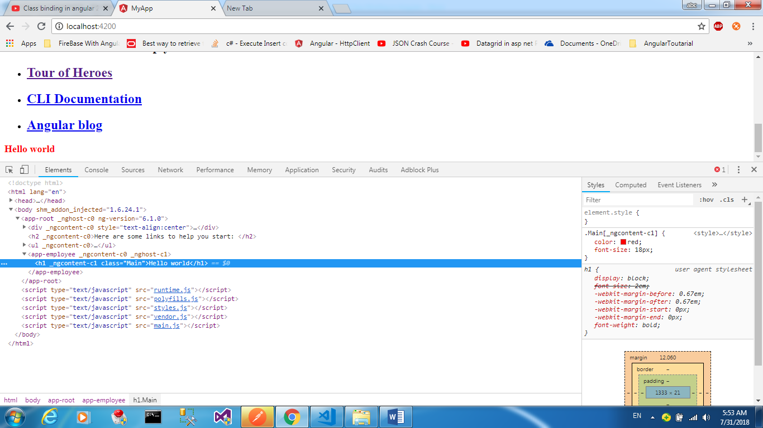

**4-If you want to add or remove multiple class we make the following steps**

**A-on the Css File we write the following code**

.Main{

color: red;

font-size: 18px;}

.MainSizeType{

font-style: italic;}

.MainLocation{

text-align: center;}

**B-on the typescript we make the following**

@Component({

selector: 'app-employee',

// templateUrl: './employee.component.html',

template: '<h1 class="Main MainFontType" [class.MainFontType]="FontTypeoApply">Hello world</h1><br/>'+

//In order to achieve the Multiple add or remove class , we use the [ngClass] that read from the styleUrls the cssClass we need and make method that return object with the property as the name exact of the cssClass

'<h1 class="Main MainFontType MainLocation" [ngClass]="AddRemoveClass()">Hello world 2</h1><br/>',

styleUrls: ['./employee.component.css']

})

export class EmployeeComponent implements OnInit {

//to add or remove class as you want all to do is make the property value true or false

public TextCenterToApply:boolean = true;

public FontTypeoApply:boolean = true;

//we see that we make function that return object with the property name is the same name of the cssClass and assign it to the property for it

AddRemoveClass()

{

let x =

{

MainFontType : this.FontTypeoApply,

MainLocation : this.TextCenterToApply

}

return x;

}